Superstore Sales Analysis
End-to-End Data Analytics Project on Superstore Dataset using Excel, SQL, Python & Power BI

Introduction:
This project focuses on analyzing the Superstore dataset to understand sales performance, profit trends, and customer behavior. The analysis is performed using Excel, SQL, Python, and Power BI to derive meaningful business insights and support data-driven decision making.

OBJECTIVE:
- To analyze sales performance of Superstore dataset
- To understand category, region, and profit trends
- To understand trends in sales over time
- To detect underperforming products and regions
- To build an interactive dashboard for business insights.

DATASET DESCRIPTION:
- Dataset name: Sample - Superstore.csv
- Key Columns: Order Date, Customer Name, Segment, Country, City, State, Region, Category, Sub-Category, Product Name, Sales, Quantity, Discount, Profit
- Type: Sales transaction data

Data Cleaning Process:
The dataset was cleaned before analysis:
- Removed duplicate and unnecessary columns
- Handled missing values (if any)
- Converted data types:
- Order Date → Date format
- Sales, Profit → Numeric format
- Created new column:
- Month-Year for time analysis
- Ensured data consistency for reporting

Excel Analysis:
Excel was used for initial exploration:
- Pivot tables created for:
- Category vs Sales
- Region vs Profit
- Charts generated:
- Bar charts for category performance
- Line charts for sales trends
- Identified basic sales patterns and trends

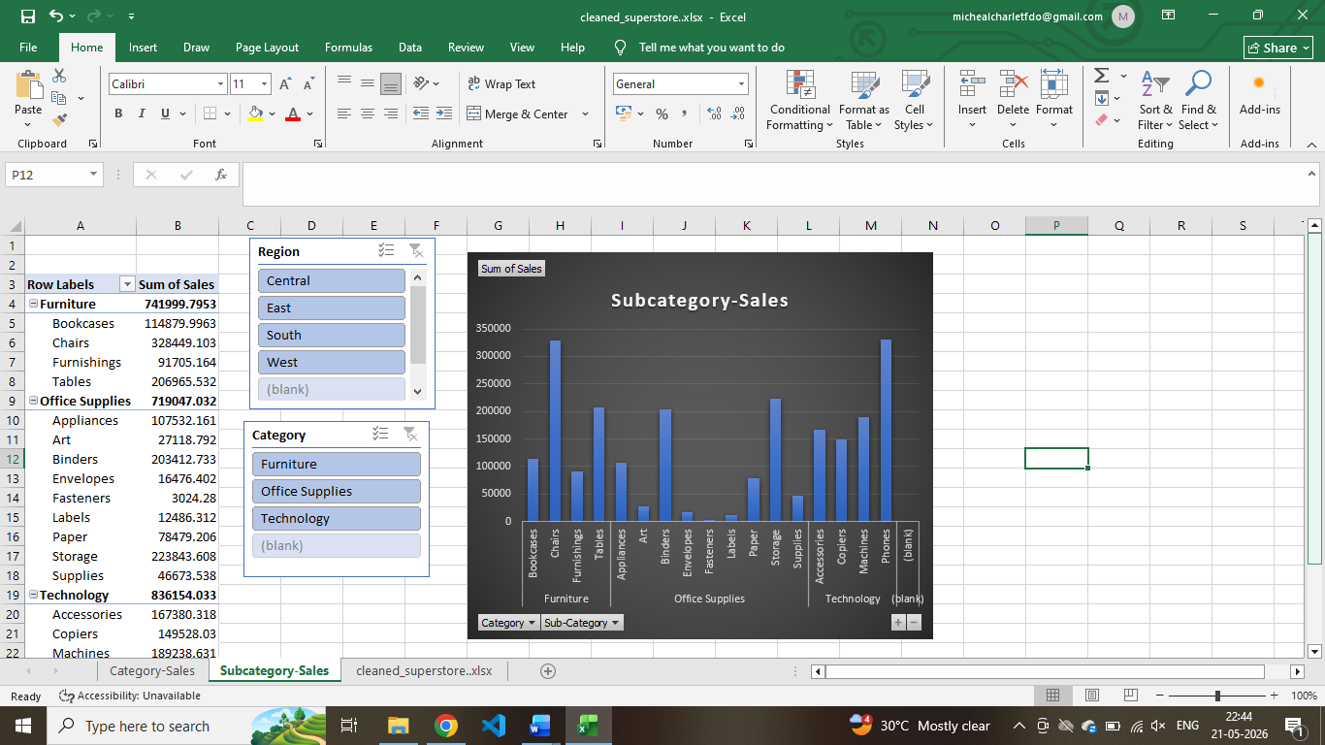

SQL Queries & Insights:
- Technology category has highest sales
- West region shows strong performance
- Some categories show low profit despite high sales

Python Visualization:
Python (Pandas & Matplotlib) used for analysis:
- Sales distribution analysis
- Profit vs Sales visualization
- Category-wise comparison
- Time series analysis of sales

Power BI Dashboard:
An interactive dashboard was created using Power BI:
Visuals Included:
- KPI Cards (Sales, Profit, Quantity)
- Monthly Sales Trend (Line Chart)
- Category vs Sales (Column Chart)
- Region vs Sales (Bar Chart)
- Sub-Category Performance
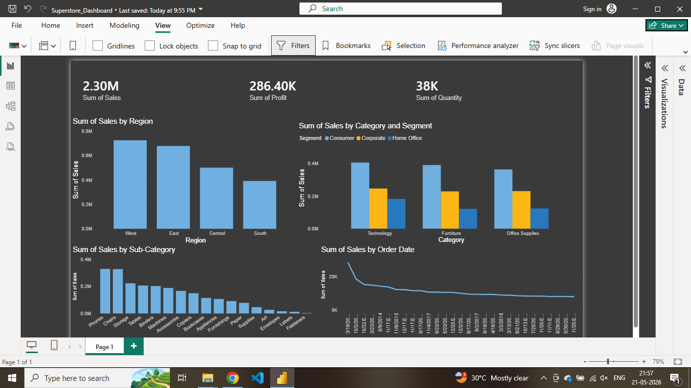

Conclusion
This project provides a complete end-to-end data analysis of the Superstore dataset using multiple tools. The insights derived help understand business performance and support strategic decision making. The Power BI dashboard provides an interactive and visual representation of key metrics for better understanding.

